Writing Your Past Into Your Fiction

Susan M. Baganz Lodwick

WHAT HISTORY?

Our personality
Meyer’s Briggs. Carl Jung

The Four Preferences In More Detail
Where, primarily, do you prefer to direct your energy?
Extravert- If you prefer to direct your energy to deal with people, things, situations, or "the outer world", then your preference is for Extraversion. This is denoted by the letter "E".
Introvert - If you prefer to direct your energy to deal with ideas, information, explanations or beliefs, or "the inner world", then your preference is for Introversion. This is denoted by the letter "I".

How do you prefer to process information?
Senser - If you prefer to deal with facts, what you know, to have clarity, or to describe what you see, then your preference is for Sensing. This is denoted by the letter "S".
INtuition- If you prefer to deal with ideas, look into the unknown, to generate new possibilities or to anticipate what isn't obvious, then your preference is for Intuition. This is denoted by the letter "N" (the letter I has already been used for Introversion).

How do you prefer to make decisions?
Thinker - If you prefer to decide on the basis of objective logic, using an analytic and detached approach, then your preference is for Thinking. This is denoted by the letter "T".
Feeler - If you prefer to decide using values and/or personal beliefs, on the basis of what you believe is important or what you or others care about, then your preference is for Feeling. This is denoted by the letter "F".

How do you prefer to organise your life?
Judger - If you prefer your life to be planned, stable and organised then your preference is for Judging(not to be confused with 'Judgmental', which is quite different). This is denoted by the letter "J".
Perceiver - If you prefer to go with the flow, to maintain flexibility and respond to things as they arise, then your preference is for Perception. This is denoted by the letter "P". http://www.teamtechnology.co.uk/tt/t-articl/mb-simpl.htm

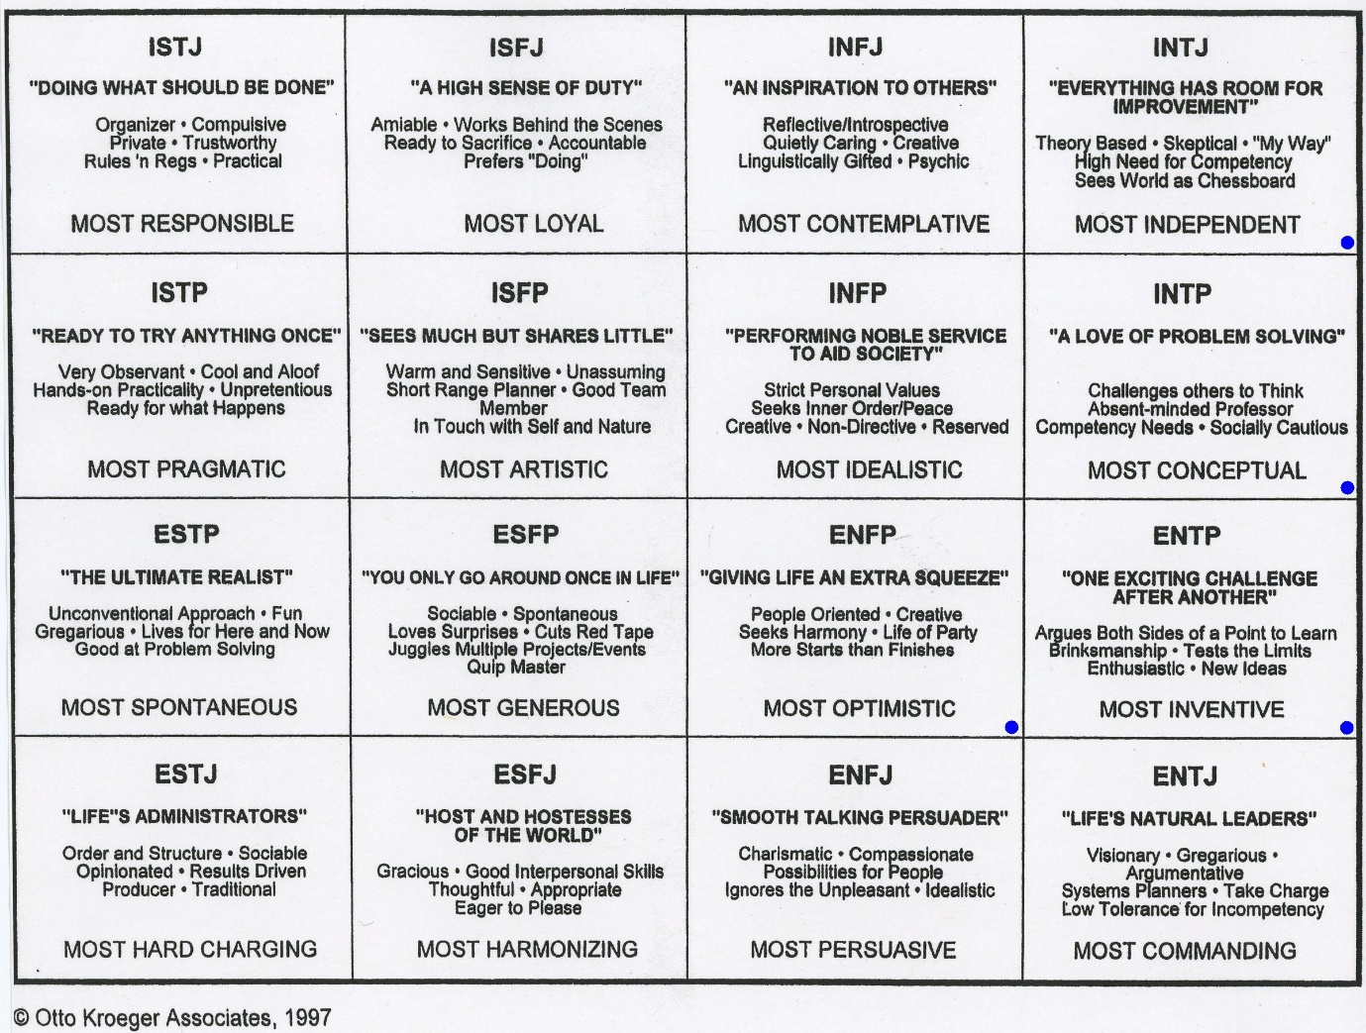
Our spiritual journey and lessons learned

The stories of people around us:

The Unconscious Leaking into Fiction

CAUTIONS

