Write His Answer Conference
Writing Levels

Beginner: You are ready to go—excited to learn how to put your writing passion into practice. You need someone to explain all the terms you hear thrown around in classes and want to know what to do first when you sit down to a blank screen or piece of paper. You might have pages that you’ve written from deep in your heart but have no idea how to even think about publishing God’s message for others to read. Maybe you’re a speaker and want to put your message in a book. You are in a wonderful stage—enjoy it fully!

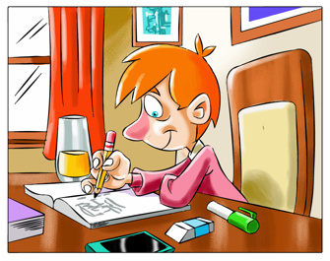
Intermediate: You’ve moved beyond the beginner stage and want to keep growing in your skills. You’ve got the basic terms down and maybe even have a book or two published. Now you want to polish what you know and learn about structure and editing. You might also be interested in building a platform, marketing, and making a decision on publishing options. You might want to learn the best practice for finding speaking engagements. And of course, it’s time to think about creating a newsletter and website. So much to do . . . but don’t screech to a stop. Instead, take your writing journey one step at a time and enjoy the trip!

Advanced: You are on a roll and have published multiple books, articles, devotions, and so on. You have a handle on how to put your thoughts on the page with clarity and connection power. But there’s always ways to drill down further—learn to utilize effective speaking techniques professional speakers use, write in deep POV to better connect emotionally with your readers, add “story” to flavor your nonfiction teaching. You diligently read and take classes to learn more about keywords and SEO so you can send God’s message further. You have a lot to share with beginner and intermediate writers and might consider mentoring at this point. Take what you know and press on!

