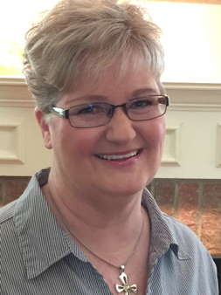
Name: Barbara E. Haley
One sentence that describes me and my writing:
I write women’s contemporary fiction, devotionals, and juvenile fiction.
Brief bio:
Barbara E. Haley lives in San Antonio, Texas, where she enjoys writing at IHOP, playing games, and spending time with her wonderful grandkids.

Why I write: I want to tell my readers what God has done in my life, especially in tough times. I write in hopes that my readers might know and grasp the depth of God’s love, His healing touch, and the joy and peace found only in Him. Whether through humorous, heart-warming fiction stories or through my blog or devotions, I want to introduce my readers to the saving truth of God’s Word.
I write:
Fiction: ___short stories _X__books
Genres: women’s contemporary fiction, juvenile chapter books
Nonfiction: ___articles ___personal experience stories _X__devotions ___books
Genres:
Other: ___poetry ___scripts
My audience _X__Christians ___general public _X__women ___men ___teens _X__children
I’m currently working on:
The fourth novel in my series “A Second Wind.”
My greatest joy and/or struggle in writing is:
Greatest joy is helping other writers. My greatest struggle is balancing my “to do” list with my “want to do” list.
I’d like to meet writers who:
___I belong to a writers’ group that is open to new members.
___I would like to find a writers’ group.
Email Address: haleybarb@yahoo.com
Website: www.barbarahaleybooks.com
Blog:
City & State (or Country):
___I’m not yet published ___I’ve been published in periodicals
__X_I have published one or more books
_X__See Book Gallery for my latest book.
Title and genre: Biz Rises to the Challenge - women’s contemporary fiction

Save as a ONE PAGE Word doc or PDF.

